* Related to the HW_3

$$\max_{x^{T}Px≤c}\left|b^{T}x\right|$$

To find you may use linear transformation, however, the alternative way I introduce

**Optimal control problem : Lagrange Multiplier (it should be known to you)v**

1. 🡪
2. 🡪
3. Then
$$b^{T}x=\frac{b^{T}\left(P^{-1}b\right)}{\frac{1}{\sqrt{c}}\left\|b^{T}P^{-\frac{1}{2}}\right\|}=\frac{\sqrt{c}}{\left\|b^{T}P^{-\frac{1}{2}}\right\|}b^{T}P^{-1}b=\frac{\sqrt{c}}{\left\|b^{T}P^{-\frac{1}{2}}\right\|}b^{T}P^{-\frac{1}{2}}{\left(b^{T}P^{-\frac{1}{2}}\right)}^{T}$$

$$\left\|b^{T}x\right\|=\sqrt{c} \left\|b^{T}P^{-\left(\frac{1}{2}\right)}\right\|$$

4. What is the meaning of this maximization problem?

$$b^{T}x=a$$

$$x^{T}Px=c$$

Given the ellipse $$x^{T}Px≤c$$

Find maximum $a$ of the straight line $b^{T}x=a$ whose $x∈the D=\left\{x: x^{T}Px≤c\right\}$

You may remember in the high school to find the point

* Related to HW_2 and HW_3 grade

You may be available to use Simulink… Nobody did it for HW..

* I will give a credit additionally for Alem, Soren, Moham

And The Mid exam result is

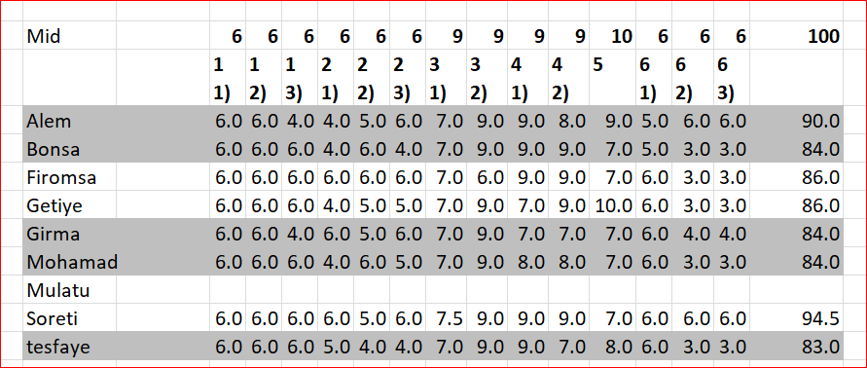

And I upload the Mid answer in Github..